[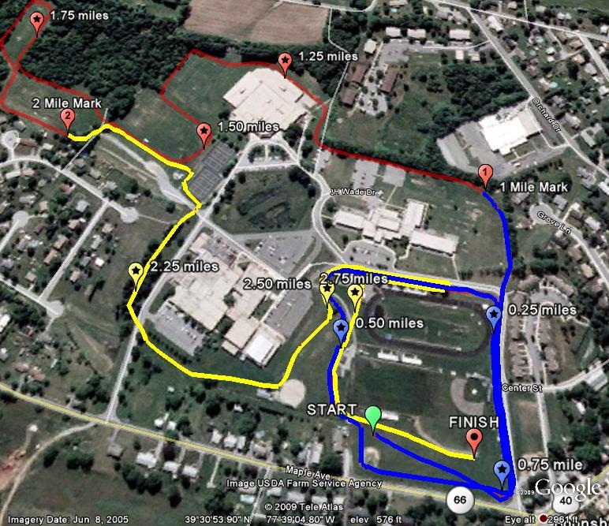](http://www.tristaterunnur.com/boonsboroxcmap.jpg)