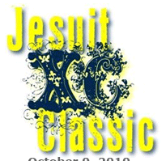

October 1, 2016

Norbuck Park ~ Dallas, TX
8:00 a.m. H.S. 5A – 6A Varsity Boys - 5000m
8:25 H.S. 5A – 6A Varsity Girls - 5000m
9:00 JV Boys - 5000m
9:30 JV Girls - 5000m
10:05 H.S. 4A & Under Varsity. Boys - 5000m
10: 30 H.S. 4A & Under Varsity Girls - 3200m
11:00 Middle School Boys - 3200m
11:25 Middle School Girls - 3200m

Race Fees
The following fees apply for each division: Make Checks Payable to “Jesuit Athletics – XC Classic”

- High School Teams - Varsity up to 9 runners; JV Unlimited. Divisions are by gender and level
- 1 Team--$100; 2 Teams--$180; 3 Teams--$250; 4 Teams--$300
- Additional Varsity "B-teams" - $50 per team
- Middle School Team - $80 per team per division – $150.00 for both girls / boys
- HS/MS Individuals - $20 per individual
- No Unattached Runners or Club Teams permitted
Send To:
Jesuit College Prep
C/O Doug Robinson
12345 Inwood Rd.
Dallas, TX 75244

All Races timed by “Run-On” using chip timing. For registration, go to: athletic.net

