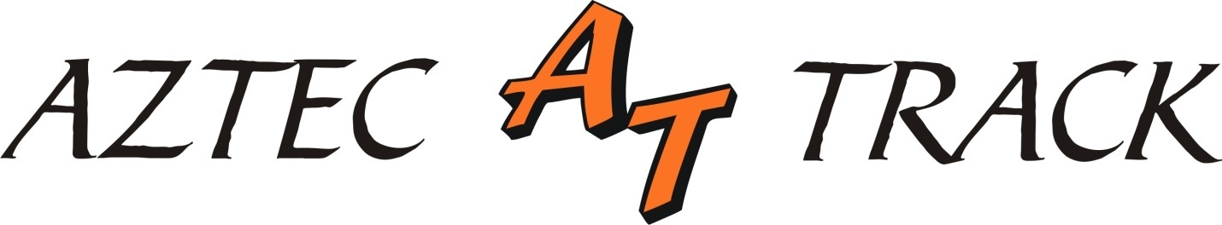

Aztec Invitational

Track & Field Meet

FRIDAY, APRIL 22, 2016
11:00 AM BOYS HIGH JUMP GIRLS JAVELIN
BOYS DISCUS GIRLS TRIPLE JUMP
BOYS POLE VAULT
12:00 PM BOYS LONG JUMP GIRLS SHOT PUT

RUNNING EVENTS DIVISION PRELIMS FINALS
3200 METER RUN GIRLS 1:00 PM
100 METER HURDLES GIRLS 1:30 PM
110 METER HIGH HURDLES BOYS 1:45 PM
100 METER DASH GIRLS 2:00 PM
100 METER DASH BOYS 2:20 PM
1600 METER RUN BOYS 2:40 PM
400 METER DASH GIRLS 2:50 PM
400 METER DASH BOYS 3:05 PM
300 METER HURDLES GIRLS 3:30 PM
300 METER HURDLES BOYS 3:50 PM
800 METER RUN GIRLS 4:10PM
200 METER DASH GIRLS 4:20 PM
200 METER DASH BOYS 4:45 PM

SATURDAY, APRIL 23, 2016

10:00 AM BOYS TRIPLE JUMP GIRLS HIGH JUMP
BOYS JAVELIN GIRLS LONG JUMP
GIRLS DISCUS
GIRLS POLE VAULT
11:00 AM BOYS SHOT PUT

RUNNING EVENTS DIVISION FINALS
4 X 800 METER RELAY GIRLS 12:00
4 X 800 METER RELAY BOYS 12:20
SPECIAL OLYMPICS GIRLS/BOYS 12:30
400 METER RELAY YOUTH 12:35
400 METER RELAY GIRLS 12:40
400 METER RELAY BOYS 12:50
100 METER HURDLES GIRLS 1:00
110 METER HURDLES BOYS 1:05
100 METER DASH GIRLS 1:10
100 METER DASH BOYS 1:15
1600 METER DASH GIRLS 1:20
800 METER RELAY GIRLS 1:30
800 METER RELAY BOYS 1:35
LUNCH BREAK
400 METER DASH GIRLS 2:30
400 METER DASH BOYS 2:35
300 METER HURDLES GIRLS 2:45
300 METER HURDLES BOYS 2:50
800 METER RUN BOYS 3:00
1600 METER MED RELAY GIRLS 3:10
1600 METER MED RELAY BOYS 3:20
200 METER DASH GIRLS 3:40
200 METER DASH BOYS 3:45
3200 METER RUN BOYS 3:50
1600 METER RELAY GIRLS 4:00
1600 METER RELAY GIRLS 4:05

