5,000 meters is 3.106856 miles
(i.e. - 3 miles and 564 feet and 2.4 inches)
The finish line is parallel to the westernmost border of the small pond (ditch) on west side of the 1st hole fairway – and parallel to 1st tree south after the opening on the east side of the fairway
SEE BELOW
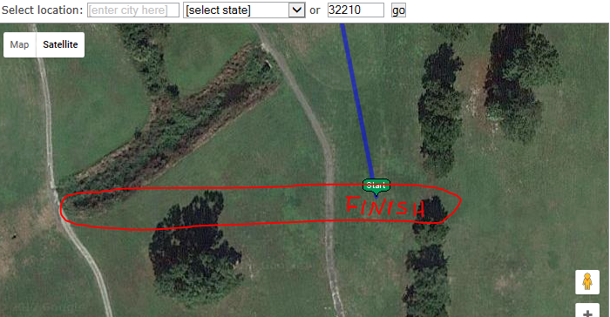

The three mile mark is wheeled 564 feet 2.4 inches backwards from finish straight down the 1st hole fairway, angling to the final right turn just past the 1st hole green
SEE BELOW
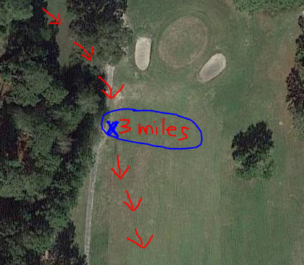

2 Mile mark is at the exact northernmost end of long narrow sand trap on the east side of the 8th hole fairway –
SEE BELOW
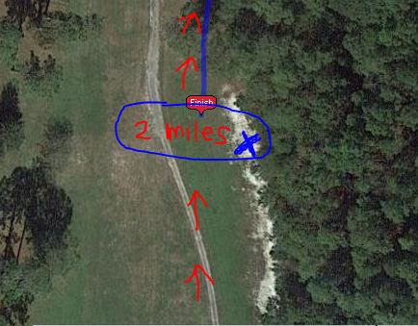
The exact halfway point is right where runners swing around the big lone oak tree (about 100 yards in front of the first hole green) – just as they end loop one and begin loop two
SEE BELOW
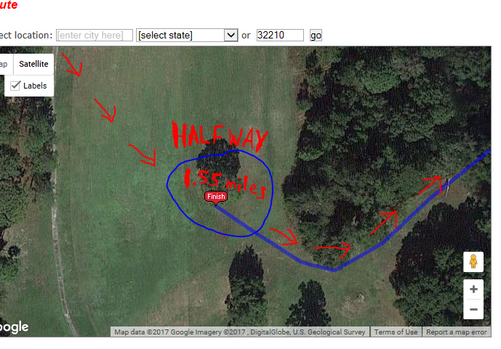
The 1 mile mark is exactly 130 feet north of "the lone palm tree" halfway down the 5th hole fairway – SEE BELOW
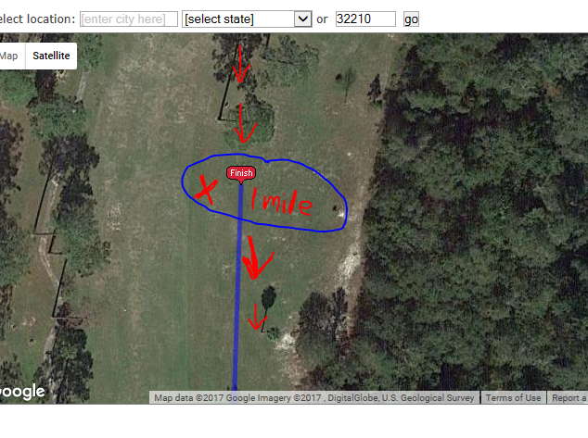
Starting Line is exactly 55 feet north of the northernmost edge of the 9th hole green (parallel to the tree trunk of the large Oak Tree on the west side of the fairway) – SEE BELOW
