ALABAMA A&M

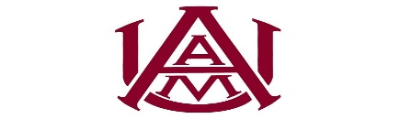
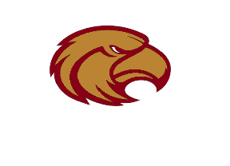
Track and Field
BULLDOG INVITATIONAL
Hosted by: Alabama A&M & Columbia H.S.

College Schedule in Red
High School Schedule in Black

Friday, April 7th
Field Events:
10:00 a m Javelin Women; (College Men to Follow)
12:00pm Pole Vault Girls; (College Men to Follow)
12:00pm Hammer Women; (College Men to Follow)
3:00pm Discus Girls; (College Men to Follow)
3:00pm Shot Put Boys; Girls to Follow
3:00pm Long Jump Girls; (Long Jump College Men to Follow)
Triple Jump Women; (Triple Jump Boys to follow)
4:00pm High Jump Girls: Boys to Follow

Running Event:2pm Start Time Rolling Schedule

5000m Men/Women to follow
4x100m Relay Timed Final (Girls/Boys to follow)
3200m Final
100m Prelim
100H Prelim
110H Prelim
800m Timed Final
300H Timed Final
400m Timed Final

Saturday, April 8th
Field Events:
10:00a m Women’s Discus; (High School Boys to Follow)
12:00pm Pole Vault Women (High School Boys to Follow)
12:00pm Long Jump Boys; (College Women to follow)
Followed by Triple College Men (High School Girls to Follow)
2:00pm Women’s Shot Put (Men to Follow)
3:00pm Men High Jump (Women to Follow)

Running Events: 10am start time Rolling Schedule
4x200m Relay Girls/Boys to follow
4x100m Relay Men/Women to follow
1500m Men/Women to follow
100H Women
100H Girls Final
110H Men
110H Boys Final
1500m Men/Women to follow
1600m Girls/Boys to follow
400m Men/Women to follow
100m Men/Women to follow
100m Girls/Boys to follow
800m Men/Women to follow
400H Men/Women to follow
200m Men/Women to follow
2000m Steeple Chase Girls/Boys to follow
4x400m Relay Men/Women to follow
4x400m Relay Girls/Boys to follow

