

Track Invitation
Date:
March 7, 2014

Location:
Calvary Christian High School
110 N. McMullen Booth Ave, Clearwater, FL 33759

Entry:
Entries will only be accepted through Elitetimeing.com.
No additions will be accepted the day of the meet.
Four entries will be accepted per event in field and laned events.
Five entries will be accepted for distance events.
One entry will be accepted for relays.
The number of teams will be limited. Your spot in the meet is not confirmed until we receive the entry fee as we have a large list of school’s wanting to attend. Please process the fees as soon as possible.
Teams confirmed in the meet will receive a code to enter athletes two weeks prior to the meet.

Fees:
$140 per gender or $250 per team
Make checks payable to Calvary Christian High School and mail to:
Calvary Christian High School
110 N. McMullen Booth Road
Clearwater, FL 33759

Admission:
$5 for adults
$2 for students (4 and under are free)

Results:
Results will be posted on elitetimeing.com.

Meet Schedule:
Coaches meeting at 3:45pm
Field events begin at 4:00pm
Running events begin at 5:30pm

PLEASE NOTE: ONLY 3/16” NEEDLE POINT SPIKES ARE PERMITTED ON THE TRACK.

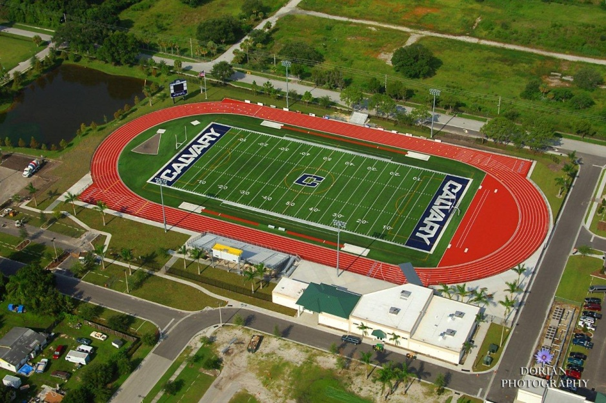
Completed in August of 2011
8 - 42” lane track; able to run in multiple directions
Two runways (four pits) for Long Jump/Triple Jump
Shot and Discus inside the track facility
All new international level pits and hurdles
Full Daktronics scoreboard with instant results posted.
Training room
1400 seats which can view events all around the track
Five hotels less than a mile from the site
Multiple restaurants less than a mile from the site

