Regular season Meet start time is 3:30pm @ Milton Frank Stadium
Meet #1 March 10th Scheduled teams = 1, 2, 3, 4, 5, 6, 7
Meet #2 March 31st Scheduled teams = 2, 3, 4, 5, 6, 8, 9
March 18th thru 28th SPRING BREAK!
Meet #3 April 7th Scheduled teams = 3, 4, 5, 7, 8, 9, 1
Meet #4 April 12th Scheduled teams = 4, 6, 7, 8, 9, 1, 2
Meet #5 April 19th Scheduled teams = 5, 6, 7, 8, 9, 1, 2, 3
Make up Dates for any meet cancelled due to weather = April 21st
Huntsville City Middle school Track & Field Championship will be held on April 26th beginning at 11 am.
Rain dates = April 27th and 28th
Important Dates: 1st practice = Feb 5th; End of Season = April 28th; Track Officials Clinic Jan 10th 1:30pm
Preseason Coaches Meeting @ Merts Center Red Room January 25th 4:00pm Please be in attendance: There will be an informal rules clinic hosted by Hall of Fame Track Coach and Master Official Robin Gaines as well as a refresher for Al.runner and milesplit web-entry by Alabama Track Coach of the Year recipient Ryan Shea.
Middle school Teams are allowed to participate in 8 meets this season however, any “Championship” meet does not count toward this total. Hsv City Schools is hosting the above 5 meets to ensure all schools at least 4 meets. Additionally we have coordinated the schedule so that you might participate in the Junior High meets listed below should you so choose. You must attend at least two meets to be eligible for the championship on April 14th.
8-2016 JHS/ Freshman Scheduled Track & Field Meets a-March 08, 2016 Tuesday 4:00 pm Meet #1 at Cullman High School, Cullman
b-March 15, 2016 Tuesday 4:00 pm Meet #2 at Pat Tramell Stadium, Scottsboro
c-March 22, 2016 Tuesday 4:00 pm Meet #3 at Bob Jones High School, Madison
d-March 29, 2016 Tuesday 4:00 pm Meet #4 at James Clemens High School, Madison
e-April 05, 2016 Tuesday 4:00 pm Meet #5 at Cullman High School, Cullman
b- April 14, 2016 Thursday 4:00 pm North Alabama Freshman/ JHS Championships hosted by Bob Jones High School at Bob Jones High School, Madison

Team Legend:

- Williams Middle School 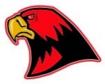
- Challenger Middle School 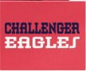
- Whitesburg Middle School
- Chapman Middle School
- Westlawn Middle School 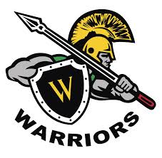
- Hampton Cove Middle School
- McNair Junior High School 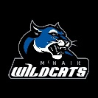
- Mt. Gap Middle School
- Huntsville Junior High School

- All HSV City Schools Meets will be AHSAA Sanctioned and feature 3 certified officials as well as the support of the University of Alabama Huntsville Track Team and Coach Cain.

