

1st Annual Sycamore Bee Sting
Middle School Track & Field Invitational
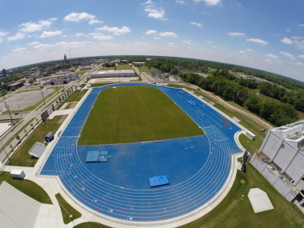
Date: April 30th, 2016
Host: Honey Creek Middle School
Location: Indiana State University
Gibson Track & Field Complex
Start Time: 10:00am (gates open at 9am)
Field Events: Starting at 10:00am
Shot put (boys followed by girls)
Discus (girls followed by boys)
High Jump (girls followed by boys) starting heights: girls 3’10”, boys 4’2”
Long Jump (boys followed by girls)
- In LJ and SP there will be three seeded flights with 9 athletes in each.
- Three throws/jumps per athlete.
- No finals.
Running Events: Starting at 10:00am
100m dash girls trials
100m dash boys trials
100m girls (30”) hurdle trials
110m boys (30”) hurdle trials

National Anthem & Announcements

Running Event Finals: Girls will run each event first followed by boys.
4x800m relay
100m hurdles
110m hurdles
100m dash
1600m run
4x100m relay
400m dash
300m low hurdles
800m run
200m dash
4x400m relay

Entries:
- Coaches MUST email their team entries to Mike Dason by Tuesday, April 26th at mrd@vigoschools.org Please enter your athletes best marks/times so that we can seed the heats. *We know that problems and injuries may occur and ask that additional changes and scratches be made on the day of the meet from 9-9:45am.
- 3 entries per field event
- 3 entries per individual running event
- 2 relay teams per event
- Maximum of 4 events per individual (may be 4 running events or a combination)
- Athletes participating must be in grades 6, 7, or 8
Awards: Team Awards: Trophies will be awarded to Boys & Girls team Champions
Individual/Relay Awards: 1st place medals, ribbons for 2nd through 6th place
Other: Pete Jones Mental Attitude Award for Outstanding Male & Female Athletes
- Athletes may pick up their awards at the finish line building after they are announced.
Admission: $5 per person or canned food donation of 3+ items (Lighthouse Mission)
Concessions: Food and drinks will be available for purchase throughout the meet.
Facility:
- The Indiana State University Gibson Track & Field Complex is located on 1st Street at the intersection of Chestnut Street.
- Parking is across the street in Lot O and Lot K
- Restrooms are available.
- Spectator bleachers are in the East side of the track.
- Team bleachers/tent area is on the West side of the track. Canopies are allowed in the grass area north or east of the track.
- Only those athletes that are participating may be on the infield or on the track.
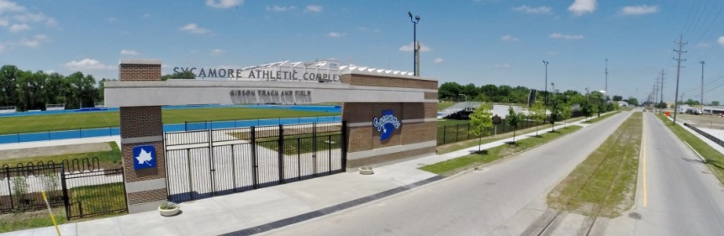
- ¼” spikes may be worn.
Questions: Contact meet director Holly Hyland at (812)462-4372 or email hhh@vigoschools.org
Meet information is also available on the Honey Creek Middle School website under “Athletics” and on Facebook at “Honey Creek Athletics”

