FAST TRACK
Youth Track & Field Club
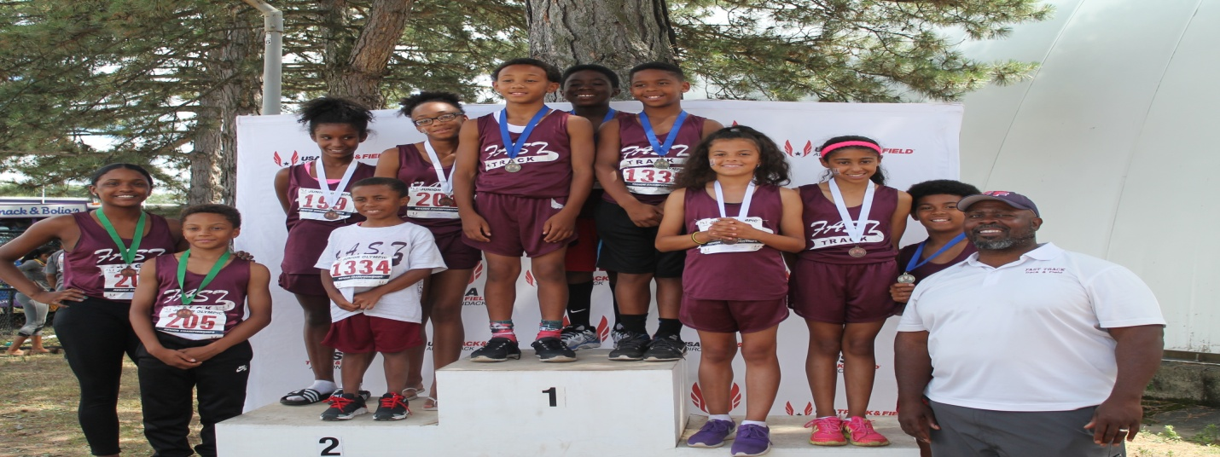

"On The FAST TRACK TO SUCCESS"

July 11, 2016

Dear Past and/ or Potential Donor:

Initially, in 2009, FAST TRACK began as a developmental youth track & field club that introduced middle school students to the sport in order for them to have interest upon entering high school. Throughout this time, FAST TRACK has developed many athletes from the developmental level into athletes who has gone on to compete in high school, Junior Olympic Championships, and on to college. More importantly, FAST TRACK encourages higher education and for athletes to use the sport of track & field as a vehicle to college.

Currently, FAST TRACK has 60 members between 7-18 years old. The program provides a positive outlet for a vast number of athletes in the Central Falls and surrounding area. TODAY, 10 deserving youth have qualified to compete at the USA Track & Field National Junior Olympic Championships (July 26-July 31) that will be held at the Sacramento State Hornet's Stadium, Sacramento, California. History will be made at this event, as this will be the second and most largest group of this size that FAST TRACK athletes has ever qualified for this high level of competition!

Unfortunately, this cannot be done without the continued and new support from our outstanding donors. It will cost each child approximately $1,200 to travel and compete at USATF National Junior Olympics. We are writing to you and asking you to help with this cost. Any amount as a donation will help. We are asking you to invest in these deserving youth and help keep them moving in the right direction. Please make your donation today. Checks can be payable to FAST TRACK and mailed to FAST TRACK, PO Box 23202, Providence, RI 02903. If you have any questions, please call Ernest Fennell at 401-286-8952.

Thank you again,

Ernest Fennell
Founder/Head Coach
FAST TRACK Track & Field Club

