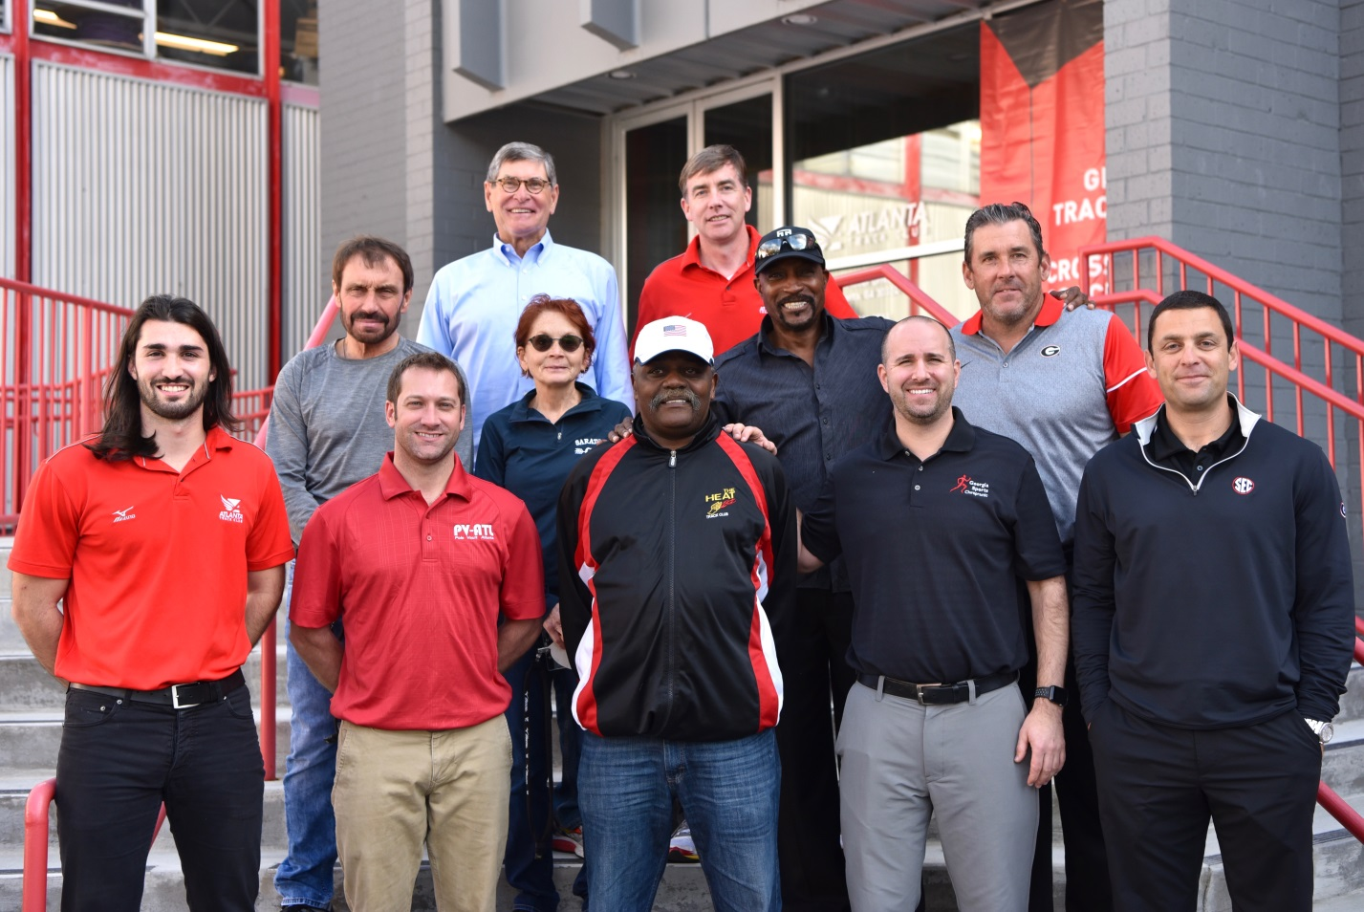

The 2017 Georgia Track & Field and Cross Country Coaches Clinic was a huge success this past weekend, with over 200 coaches from 93 different programs. In its second year hosting, Atlanta Track Club brought together a top-notch group of speakers including Olympic, college, and high school coaches.

The event kicked off Friday evening with Jim Ryun and Harvey Glance hosting sessions on goal setting and coaching philosophy. Following the two Friday sessions was the first Coaches Social held at American Spirit Works. Coaches mingled over dinner and heard from Jim Ryun about the coaches who had the most influence on his high school and professional running career.

Jim Ryun: Guest Speaker at Coaches Social Friday Evening

On Saturday, the day was filled with 25+ sessions covering all track & field disciplines, Coaches panels for both sprints and distance, and the GHSA Rules Clinic. The coaches panel was a great addition to the clinic this year, providing coaches the opportunity to ask questions of other successful Georgia programs as well as the speakers.

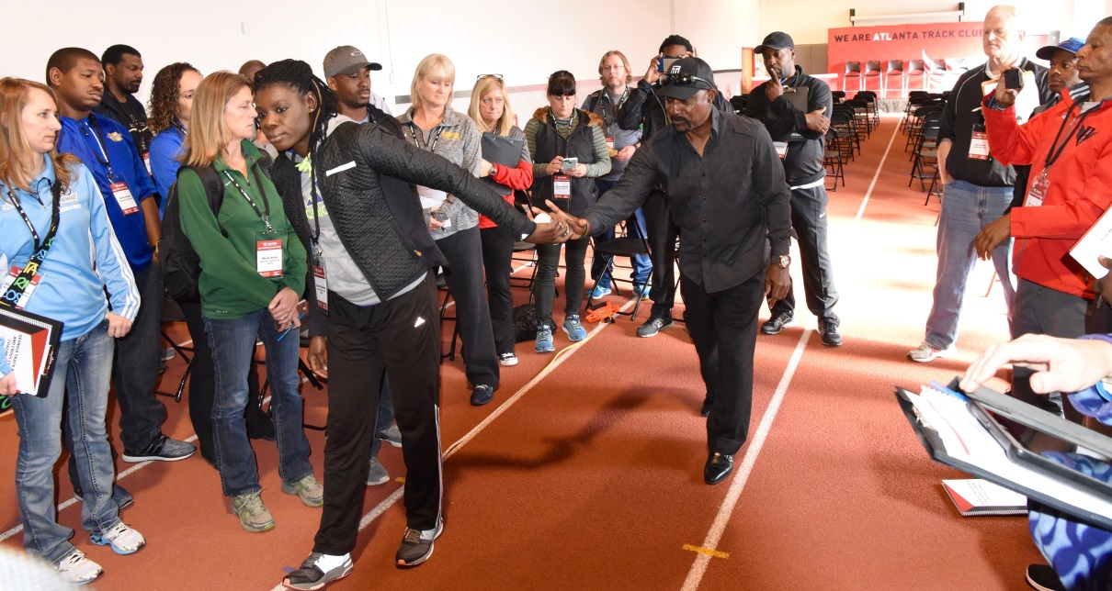
Harvey Glance demonstrating handoffs on Atlanta Track Club indoor 50 meter track
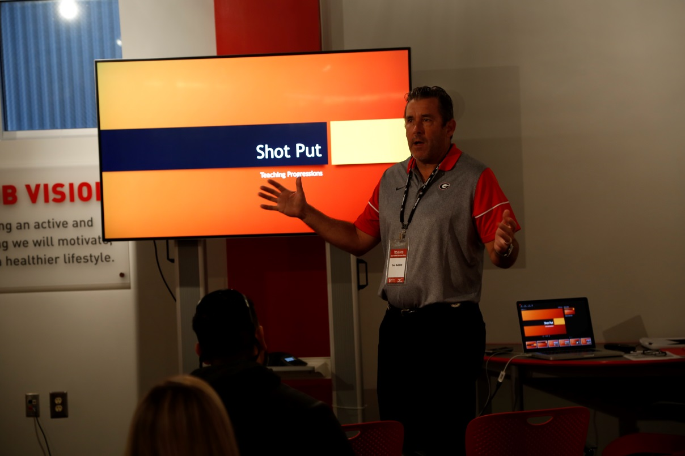
Don Babbitt, UGA Throws Coach, teaching shotput progressions

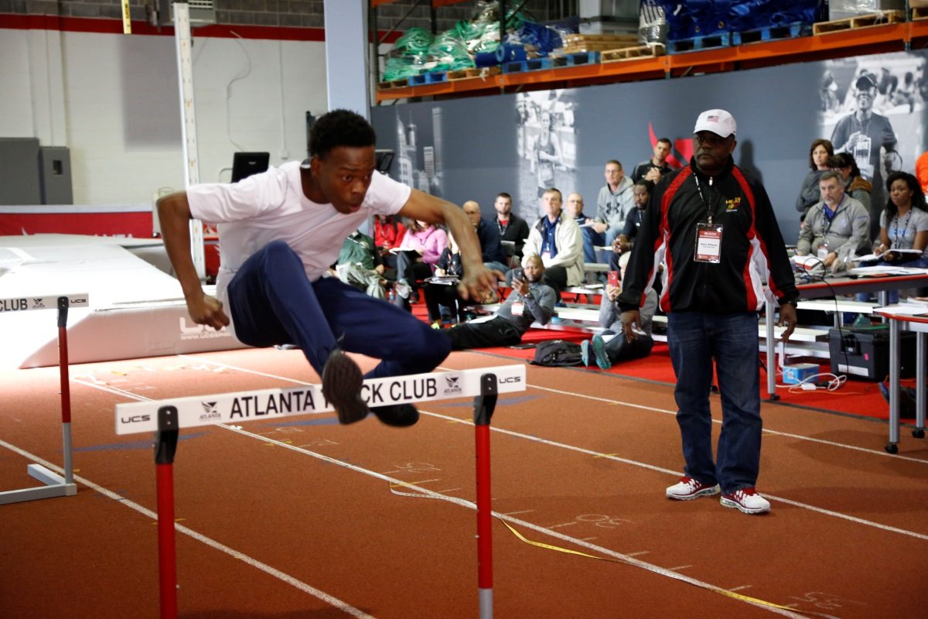
Blane Williams, Heat Track Club, Hurdles Training and Common Problems

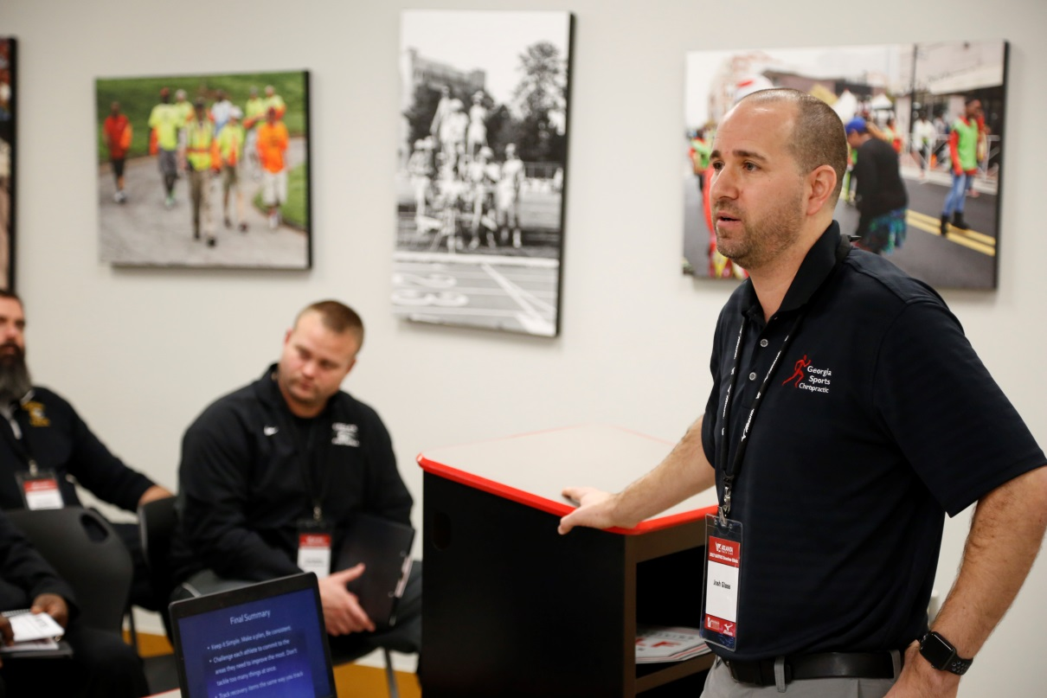
Dr. Josh Glass, Gold Medal Recovery Lessons from Rio

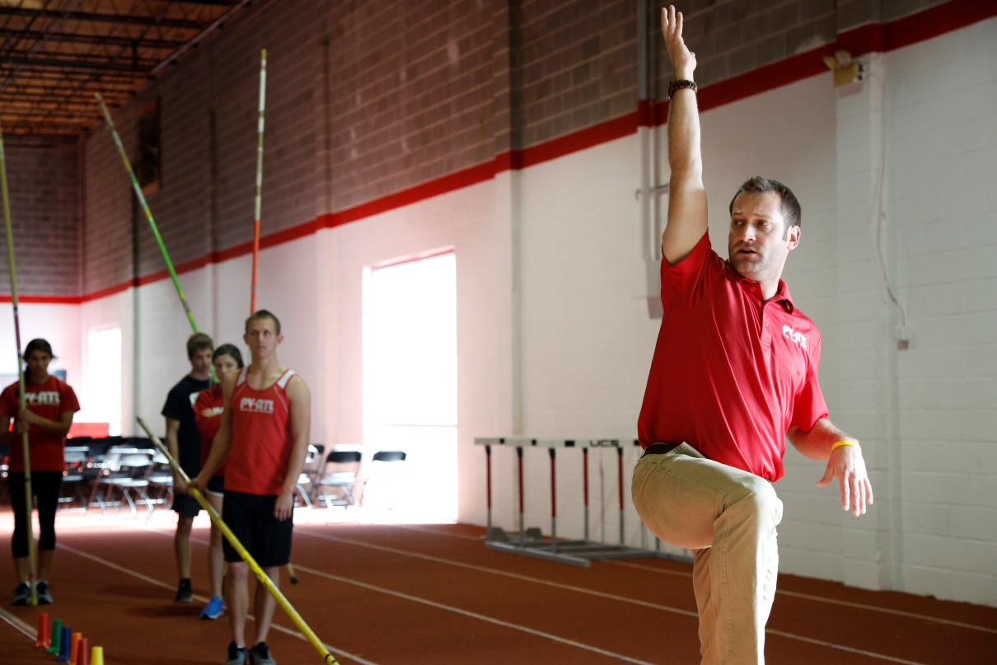
Matt Barry, PVATL, demonstrating various Pole Vault Drills
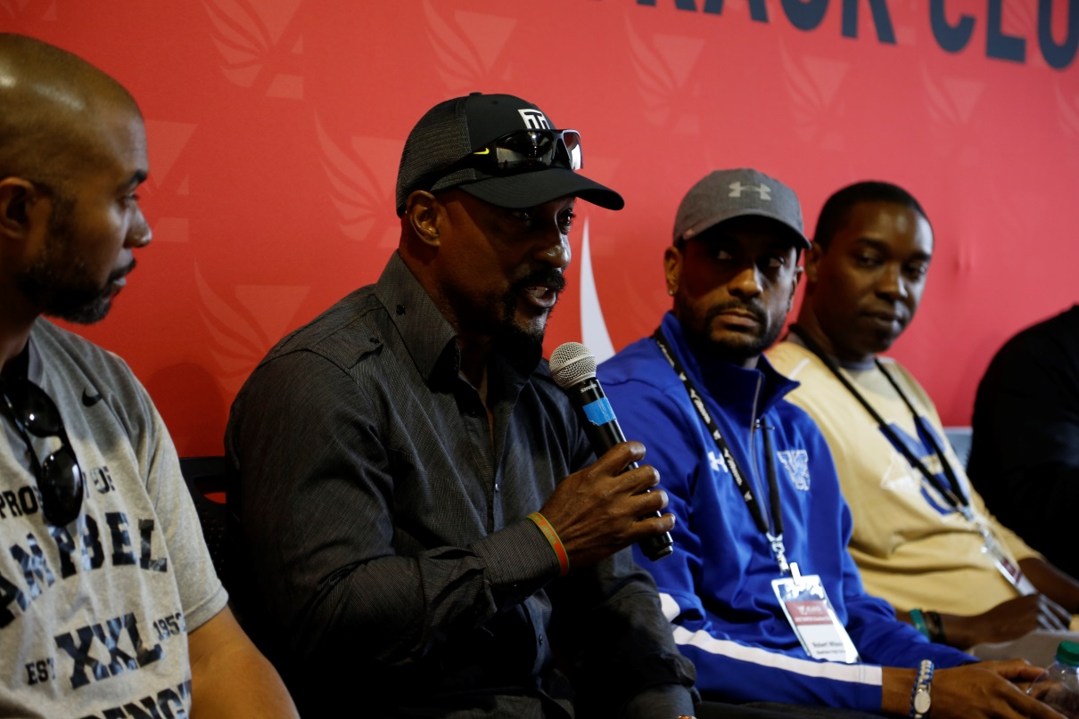
Sprint Coaches Panel from left, Brian Smith (Campbell), Harvey Glance, Robert Wilson (Westlake), Cedric Sapp (McEachern), Petros Kyprianou

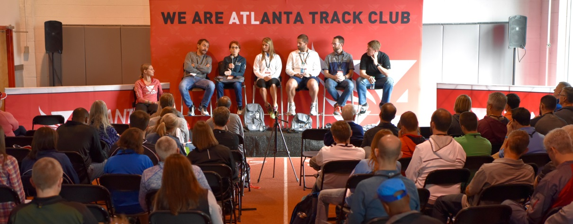
Distance Coaches Panel from left, Amy Begley (Atlanta Track Club), Art & Linda Kranick (Saratoga Springs), Jeannie Leford (Towns Co.), Ryan McClay (St. Pius X), Eric Heintz (Marist), James Tigue (Lambert)

Atlanta Track Club is committed to creating an active and healthy Atlanta through running and walking. It was originally founded in support of high school track & field and cross country. This year Atlanta Track Club will support the high school running community with events and programs such as the Coaches Clinic, All-Comers Meets & All-Star Mile, Cross Country Running Camp at Berry College, Wingfoot XC Classic, and All-Metro Track & Field and Cross Country Banquets,. Additionally the Club will serve as presenting sponsor for the GHSA State Track and Cross Country Championships and Team Georgia as well as provide college scholarships. For more information about Atlanta Track Club visit atlantatrackclub.org/high-school-running

